Professional Bio for Anni Silverdale Poole Transformative Coach, Mum, and Executive Grandma!
“My coaching is rooted in compassion, blending psychological insight with spiritual intuition. I listen from a deeply sacred space of who you truly are, perfect, whole, and free.” I believe that we can manage our own mental resources in a way that brings freedom from stress and allows a perfect way of being well. Anni _____________________________________________

Anni Silverdale is a successful transformative coach, counsellor, and author with over 25 years of leading in education in the UK. Anni was born in the beautiful English Lake District, and the expansiveness of that landscape created her philosophy of ‘anything is possible,’ her coaching vision. Anni has a son who transitioned by suicide in 2022 and currently leads a support group for grieving parents.

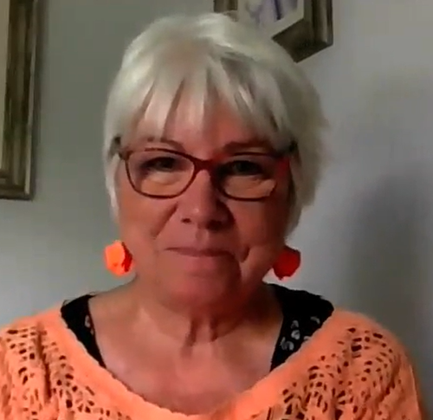
Anni founded her coaching business in 2009, she is a certified Transformative Coach, a High-Performance Business coach, having an MBA in Mental Health. She has Advanced Skills in Counselling an English degree, National UK Leadership NPQH qualifications has been a consultant across the North of England.

Anni offers a range of training and coaching delivered to serve the needs of individual clients, businesses, and communities. Well-being is a culture – a way of being that allows mistakes, embraces courage, builds stamina, and engages humour.
Anni trained internationally with Michael Neill in 2013 and mentored by Dr Judy Sedgeman ED.in 2015 -16. Anni then rained with Brendan Burchard’s High Performance Growth Coaching in 2020 and recently Anni was coached and mentored by Dr Linda Sandel Pettit an experienced senior psychologist, in 2023-24. Anni has presented in person to conferences in Spain and Africa, America, and Europe and throughout the UK.
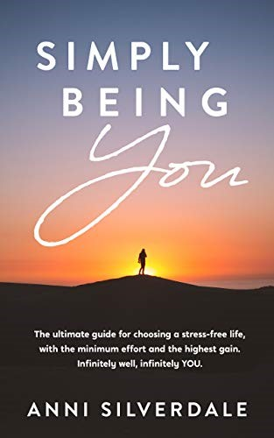
Anni continues to deepen her grounding, learning how to simplify her intuitive coaching in action - in life completing her inner MBA in 2025. She knows firsthand how crucial coaching can be for mental wellness -particularly at times of deepest challenge.
Anni specialises in life and leadership coaching; she has vast knowledge of whole community well-being and is the author of a book entitled. Simply Being YOU
https://www.amazon.co.uk/Simply-Being-YOU-Infinitely-infinitely-ebook/dp/B07P45NQ8R/It is written especially for all human beings, carers, parents’ teenagers. FOR ALL adults and teens on this planet. www.annipoole.com
Anni can be found here:
Anni Silverdale Poole - YouTube AnniPoole annisilverdale

